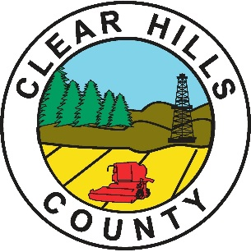

Clear Hills County

Agricultural Service Board

Vision

Agricultural Industry that is environmentally sustainable, economically progressive, innovative and diverse

Mission

To develop and implement policies and programs that advise and assist agricultural producers and Council to enhance and sustain agriculture within Clear Hills County

Values

The ability of farmers to practice all types of agriculture

Clean water, clean air, and happy, healthy people

Good communication with producers, consumers and residents

Respect for agricultural producers, consumers and residents

Environmentally beneficial land use practices

Protecting riparian areas and water ways

Protecting and promoting private and community woodlots

Promote soil conservation practices

Balance and diverse agricultural land use that meets the needs of County residents, producers and consumers

